HILLY FIELDS FOOTBALL CLUB
SEASON 26: 1992-93
Beckenham Hospital Veterans Cup
P W D L F A
1 0 0 1 3 4
Friendly 29 10 6 13 76 80
TOTAL 30 10 6 14 79 84

Apps Gls Apps Gls
Irving Bartlett 1 2 Mark Kellaway 5 10
Adrian Bennett 25 0 John Kennedy 4 4
Mark Burgess 1 0 Kevin Keogh 1 0
Mark Cooper 20 4 Mike Lane 20 0
Micky Davis 6 0 Jim Lordan 1 0
Kevin Dennis 1 1 John Macrea 2 0
Steve Duffy 1 1 Kevin McCormick 1 0
Terry Dyke 2 0 Alan McLaren 2 0
Steve Edwards 15 0 Steve Morton 15 15
John Felton 20 0 Richard Patterson 24 15
Keith Foster 23 3 Gary Platt 2 3
Len Franklin 6 2 Steve Quinn 19 2
Larry Garnham 1 0 Geoff Roberts 4 0
Stuart Harris 1 0 Alan Sayers 1 0
Malcolm Hill 15 1 Ralph Stanton 7 5
Phil Hortin 16 0 Albert St Clair 11 2
Mike Jefferys 19 3 Rick Symes 5 0
Phil Jesson 2 0 Mario Vaz 14 0
Howard Jones 4 3 Dave Wright 18 2
Mark Jowitt 1 0 OG 1
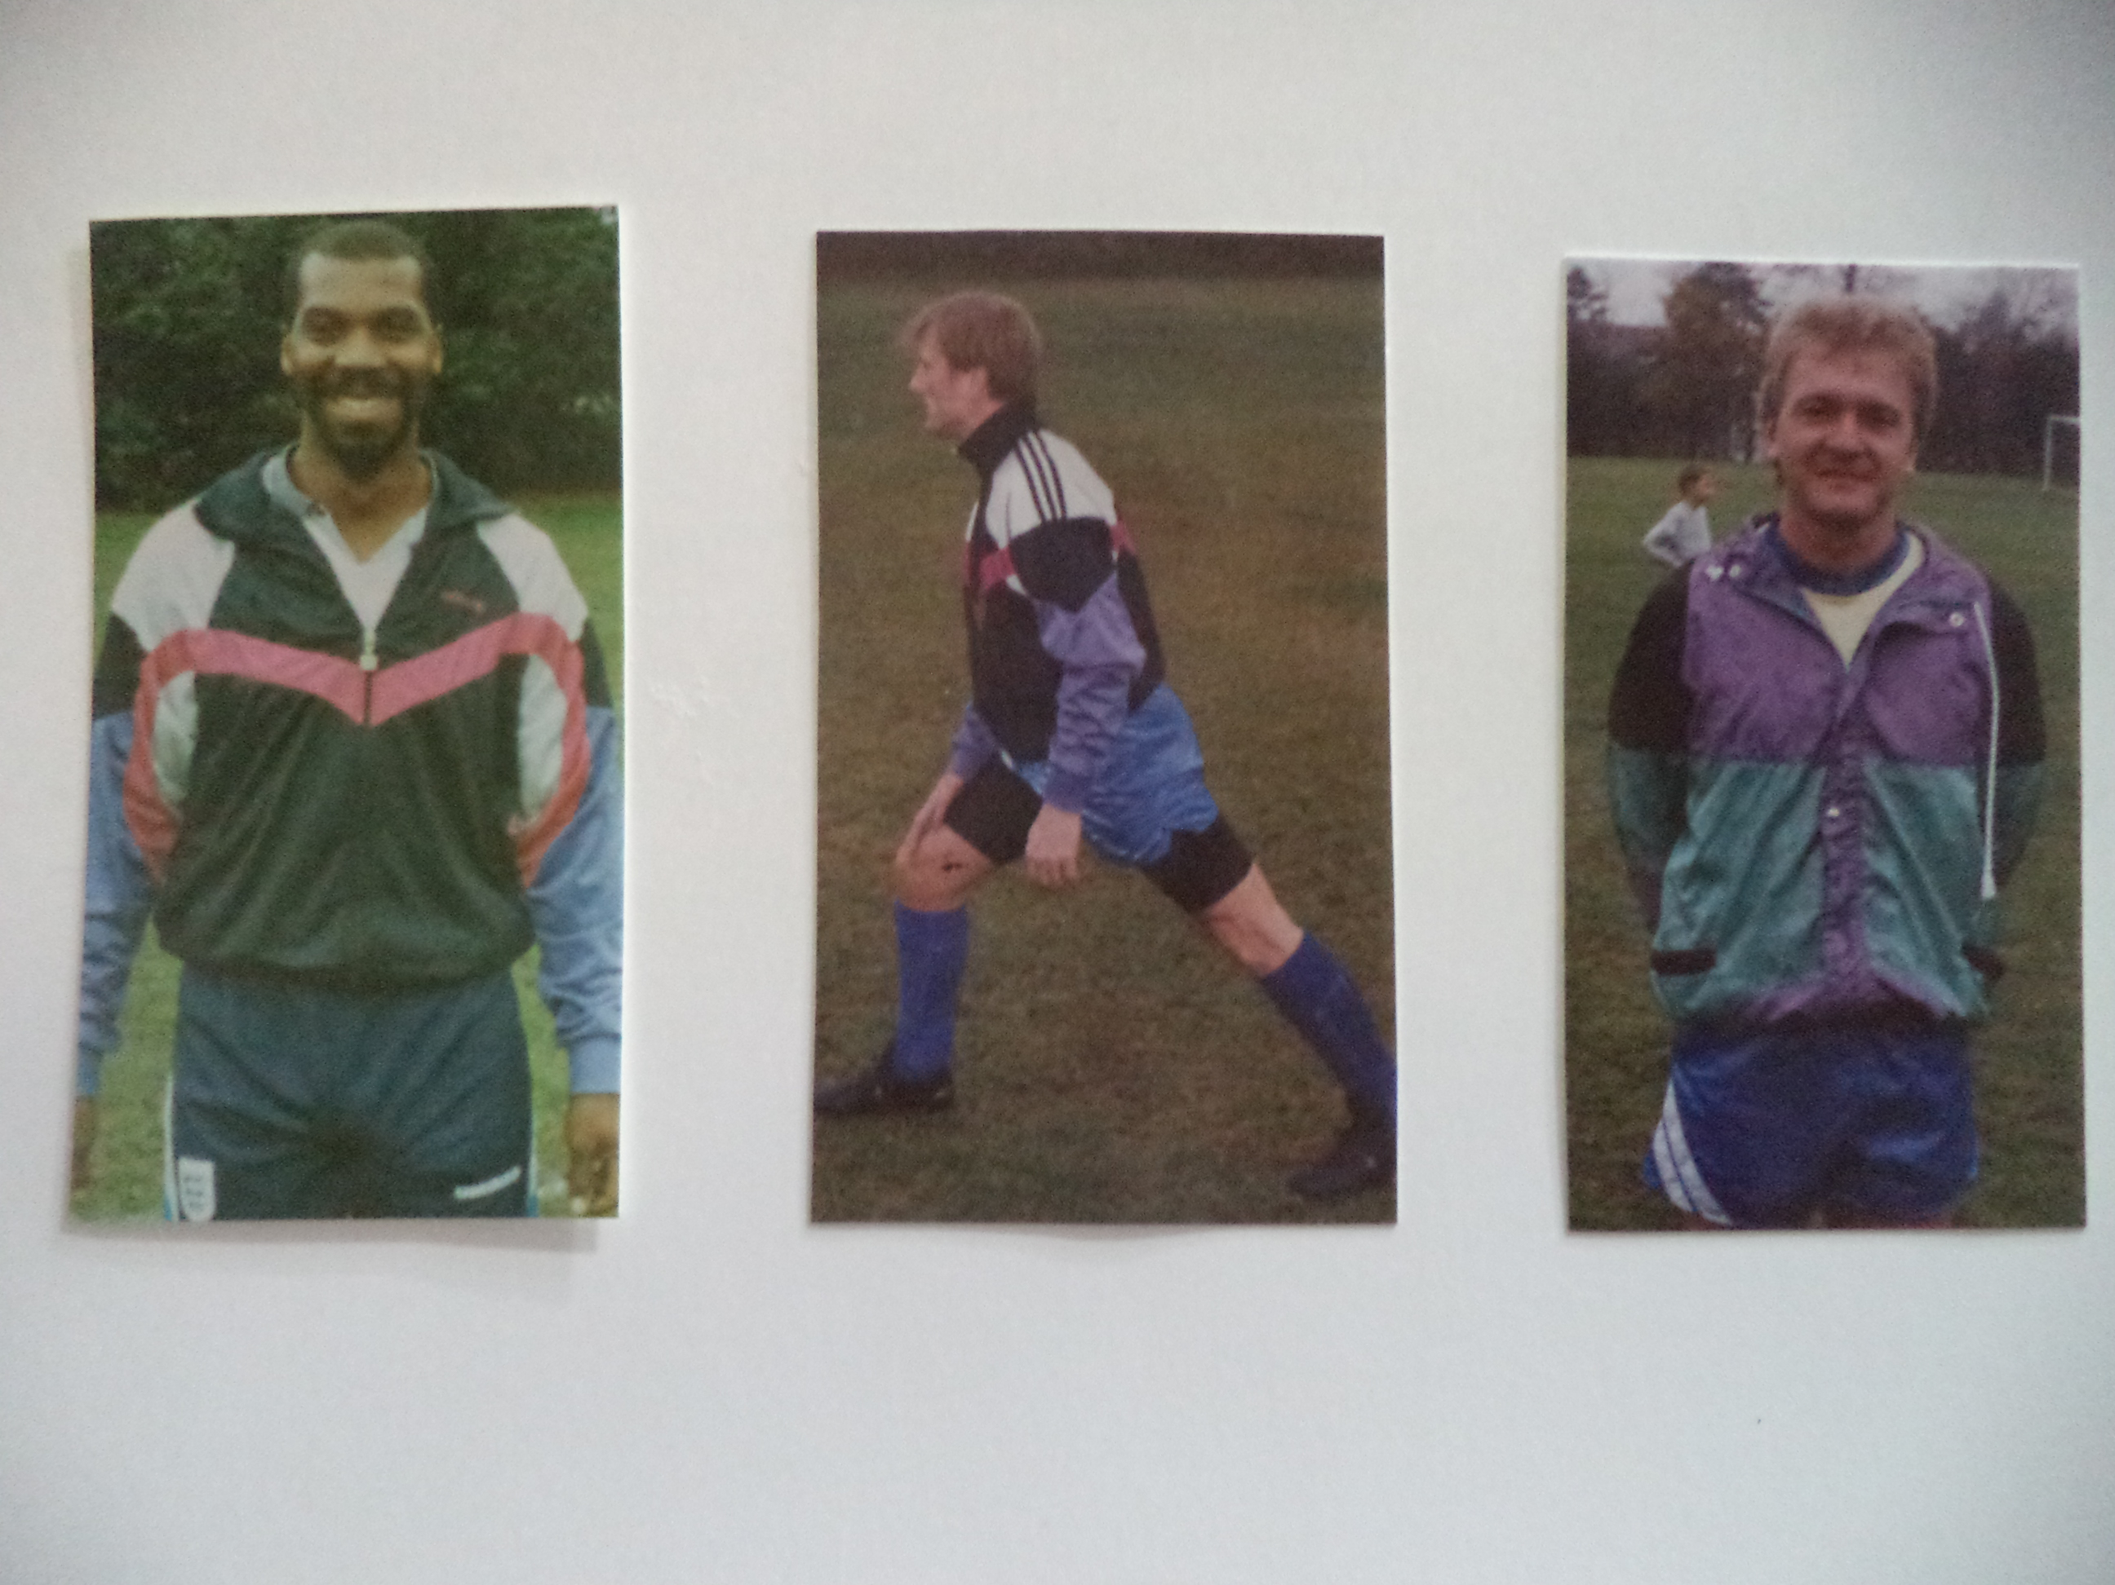
Irving Bartlett Mike Jefferys Steve Quinn

